FRAUD DETECTION AND ANALYSIS FOR INSURANCE CLAIM USING MACHINE LEARNING
ABSTRACT:
Insurance fraud poses a major challenge for insurance companies, leading to significant financial losses annually. Traditional fraud detection methods, which rely on manual claim reviews, are often inefficient, time-consuming, and prone to errors. Machine learning (ML) presents a powerful alternative by automating the identification of fraudulent claims.
This study proposes a novel ML-based approach to detecting fraud in insurance claims using a supervised learning algorithm. The model is trained on historical insurance claim data containing both fraudulent and legitimate cases. Key features used for classification include claim type, claim amount, and policyholder history.
The proposed approach was evaluated on real-world insurance claim data, demonstrating high accuracy in fraud detection. Additionally, it successfully identified fraudulent claims that traditional methods failed to detect. By automating fraud detection, this approach enhances efficiency, allowing investigators to focus on complex cases while reducing the financial impact of undetected fraud.

INTRODUCTION
Insurance fraud involves making false or exaggerated claims to receive unauthorized financial benefits from an insurance company or underwriter. Fraudulent activities are particularly prevalent in motor and general insurance sectors, leading to substantial financial losses.
Fraud can originate from multiple sources, including policyholders, intermediaries, or internal actors within the insurance system, with the latter two posing greater challenges in regulatory oversight. These fraudulent activities encompass various deceptive practices such as misrepresentation, identity fraud, staged accidents, and inflated claims.
Common fraud schemes include falsifying application details, exaggerating damages, fabricating incidents, or misrepresenting the circumstances of a claim. In some cases, claimants attempt to shift responsibility for an incident, fail to adhere to required safety measures, or overstate the extent of damages. Additionally, fraudulent claims may involve inflating losses by including unrelated damages or assigning excessive monetary values to reported losses.
The increasing complexity of insurance fraud necessitates more robust detection mechanisms to mitigate financial risks and maintain the integrity of the insurance industry.

Scope:
The scope of this project focuses on developing an automated fraud detection system for insurance claims using machine learning (ML) techniques. The system aims to analyze historical claim data to identify fraudulent patterns and classify claims as legitimate or fraudulent. The project encompasses the following:
- Implementing supervised learning algorithms for fraud detection.
- Utilizing key claim-related features such as claim type, amount, and policyholder history.
- Evaluating and comparing different ML models for accuracy and efficiency.
- Automating fraud detection to reduce manual efforts and enhance decision-making.
- Integrating the model into an application for real-time fraud analysis.

Objective:
The main objective of this project is to develop a machine learning-based solution that improves fraud detection accuracy in insurance claims. Specific objectives include:
- Data Collection & Processing: Gathering and preprocessing insurance claim datasets.
- Feature Engineering: Identifying key attributes that contribute to fraud detection.
- Model Development: Implementing and training machine learning models (such as Decision Tree, Random Forest, SVM, XGBoost).
- Evaluation & Optimization: Measuring model performance and fine-tuning it for better accuracy.
- Automation & Implementation: Integrating the ML model into an automated system to assist insurers in real-time fraud detection.

Goal:
The ultimate goal of this project is to create an efficient, reliable, and scalable fraud detection system that enhances the ability of insurance companies to:
- Reduce financial losses by detecting fraudulent claims early.
- Improve efficiency by minimizing manual reviews and investigations.
- Enhance fraud prevention by identifying new fraud patterns.
- Ensure fairness by distinguishing between legitimate and fraudulent claims accurately.
- Support decision-making by providing insights into fraudulent claim trends.

Existing System:
Traditional fraud detection in insurance claims relies heavily on manual processes and rule-based methods. These methods include:
- Manual claim review: Insurance investigators analyze claims based on predefined rules and historical fraud patterns.
- Rule-based detection: Fixed conditions (such as high claim amounts or repeated claims) trigger fraud alerts.
- Customer history checks: Previous fraudulent activities are used to assess risk.
- Human expertise: Fraud detection is primarily dependent on expert judgment and experience.

Disadvantages of the Existing System:
- Time-Consuming: Manual reviews require significant time, delaying claim processing.
- Error-Prone: Human judgment is subjective and prone to inconsistencies.
- Limited Scalability: As the volume of claims increases, manual methods become inefficient.
- Pattern Recognition Challenges: Rule-based systems struggle to detect new and evolving fraud techniques.
- High Operational Costs: Increased manpower and investigation efforts lead to higher expenses.
- Reactive Approach: Fraud is often detected after the claim is processed, leading to financial losses.

Proposed System:
The proposed system leverages Machine Learning (ML) algorithms to automatically detect fraudulent insurance claims. This system involves:
- Supervised learning models trained on historical insurance claim data.
- Feature engineering to analyze important claim-related variables.
- Automated fraud classification to categorize claims as legitimate or fraudulent.
- Continuous learning to adapt to new fraud patterns and improve accuracy.

Advantages of the Proposed System:
- Increased Accuracy: ML models detect fraud patterns more effectively than rule-based methods.
- Faster Processing: Automation reduces the time required for fraud detection and claim approval.
- Scalability: The system can handle large volumes of claims without additional manpower.
- Adaptability: ML algorithms continuously learn from new data, improving fraud detection over time.
- Cost Efficiency: Reduces investigation costs by filtering out legitimate claims early.
- Real-Time Detection: Identifies fraudulent claims at the early stages of processing, preventing financial losses.
- Data-Driven Insights: Provides analytical insights into fraud trends and behaviors.

SYSTEM REQUIREMENTS:
HARDWARE REQUIREMENTS:

- System : Pentium IV 2.4 GHz.
- Hard Disk : 40 GB.
- Floppy Drive : 1.44 Mb.
- Monitor : 15 VGA Colour.
- Mouse : Logitech.
- Ram : 512 Mb.

SOFTWARE REQUIREMENTS:

- Operating System: Windows
- Coding Language: Python 3.7

LITARATURE REVIEW:
Insurance companies, operating as commercial enterprises for several years, have increasingly faced fraudulent claims across various types of insurance. [1]The financial impact of these fraudulent activities is substantial, posing serious challenges for both insurers and regulatory authorities.[1] Governments and organizations are actively working to detect and mitigate such fraudulent practices.
Among different types of insurance fraud, auto insurance fraud is one of the most prevalent, often involving fabricated accident claims. [1]To address this issue, this project focuses on analyzing insurance claim data to identify fraudulent and false claims.[1] Machine learning (ML) algorithms are implemented to develop a predictive model capable of classifying claims as legitimate or fraudulent. Additionally, a comparative analysis of different ML algorithms is conducted using performance metrics such as accuracy, precision, recall, and confusion matrix evaluations.
The project utilizes PySpark within Python to build and validate the fraud detection model, ensuring efficient processing of large-scale insurance datasets. [1]By leveraging ML techniques, the system aims to enhance fraud detection accuracy, reduce financial losses, and improve the overall efficiency of insurance claim processing.
The primary objective of this study is to develop a fraud detection model that aids insurance companies in making informed decisions and enhances their ability to combat fraudulent claims. [2]This model is based on systematically identifying and utilizing key fraud indicators to assess the likelihood of a claim being fraudulent.
To achieve this, the study proposes a structured procedure to isolate the most significant fraud indicators from a given dataset. [2]This approach was applied to data from the Dionne-Belhadji study (1996), where 23 out of 54 indicators were identified as highly relevant in predicting fraudulent activities.
Additionally, the study evaluates the model’s accuracy and fraud detection capabilities by comparing its results with detection rates obtained by insurance adjusters. [2]It also considers the possibility that traditional detection rates may underestimate the true extent of fraud, as suggested in prior research (Caron-Dionne, 1998).
Insurance fraud is a deliberate illegal activity aimed at gaining financial benefits through false claims, posing a significant challenge for insurance companies worldwide. [3]One of the primary causes of undetected fraudulent claims is the presence of investigative gaps, which allow fraudulent activities to go unnoticed. [3]To address this issue, the need for advanced computational tools has grown, enabling the automation of fraud detection and minimizing financial losses.
This study focuses on developing a reliable and efficient system for fraud detection by leveraging Data Analytics and Machine Learning techniques. [3]By automating the evaluation of insurance claims, the proposed approach enhances accuracy in identifying fraudulent activities while providing a secure and trustworthy environment for genuine policyholders.
Insurance companies have been increasingly facing fraudulent claims across various domains, leading to substantial financial losses. [4]Fraudulent claims, particularly in high-risk sectors like auto insurance, pose a major challenge as false accident claims are among the most common types of fraud. [4]To address this issue, both governmental and private organizations are actively working to detect and mitigate such fraudulent activities.
This project aims to develop a machine learning-based system to analyze insurance claim datasets and identify fraudulent claims. [4]The system employs various machine learning algorithms to classify claims as legitimate or fraudulent. Additionally, a comparative analysis of different classification models is conducted using performance metrics such as accuracy, precision, and recall, with evaluation through a confusion matrix. [4]For enhanced efficiency in fraud detection, the model is built using the PySpark Python library, enabling scalable and high-performance processing of large datasets.
Electric motors are widely used in various applications, making their reliability and longevity crucial. [5]However, they are susceptible to multiple faults, such as rotor bar breakage, short-turn faults, and bearing failures. [5]Among these, bearing failures contribute to approximately 42% of all motor faults, leading to increased vibrations, overheating, and structural damage due to continuous operation. These unexpected failures negatively impact workplace productivity and organizational profitability.
To address this issue, transitioning from scheduled maintenance to predictive maintenance is essential. [5]This chapter introduces an Internet of Things (IoT)-based solution for real-time monitoring of induction motor vibrations. [5]A decision support system, utilizing log data analysis and the Naïve Bayes classifier, evaluates vibration patterns to detect anomalies. [5]The proposed system identifies critical vibration levels and alerts users to potential motor failures, enabling timely intervention and reducing downtime.

SYSTEM STUDY

FEASIBILITY STUDY
The feasibility of the project is analyzed in this phase and business proposal is put forth with a very general plan for the project and some cost estimates. During system analysis the feasibility study of the proposed system is to be carried out. This is to ensure that the proposed system is not a burden to the company. For feasibility analysis, some understanding of the major requirements for the system is essential.
Three key considerations involved in the feasibility analysis are
- ECONOMICAL FEASIBILITY
- TECHNICAL FEASIBILITY
- SOCIAL FEASIBILITY
ECONOMICAL FEASIBILITY
This study is carried out to check the economic impact that the system will have on the organization. The amount of fund that the company can pour into the research and development of the system is limited. The expenditures must be justified. Thus the developed system as well within the budget and this was achieved because most of the technologies used are freely available. Only the customized products had to be purchased.
TECHNICAL FEASIBILITY
This study is carried out to check the technical feasibility, that is, the technical requirements of the system. Any system developed must not have a high demand on the available technical resources. This will lead to high demands on the available technical resources. This will lead to high demands being placed on the client. The developed system must have a modest requirement, as only minimal or null changes are required for implementing this system.
SOCIAL FEASIBILITY
The aspect of study is to check the level of acceptance of the system by the user. This includes the process of training the user to use the system efficiently. The user must not feel threatened by the system, instead must accept it as a necessity. The level of acceptance by the users solely depends on the methods that are employed to educate the user about the system and to make him familiar with it. His level of confidence must be raised so that he is also able to make some constructive criticism, which is welcomed, as he is the final user of the system.

SYSTEM DESIGN
SYSTEM ARCHITECTURE:

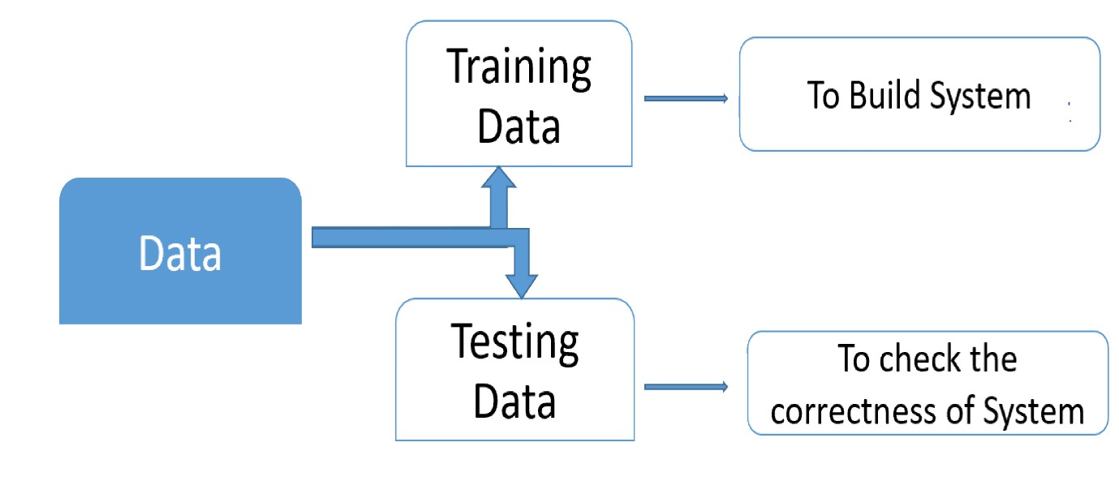

UML DIAGRAMS

UML stands for Unified Modeling Language. UML is a standardized general-purpose modeling language in the field of object-oriented software engineering. The standard is managed, and was created by, the Object Management Group.
The goal is for UML to become a common language for creating models of object oriented computer software. In its current form UML is comprised of two major components: a Meta-model and a notation. In the future, some form of method or process may also be added to; or associated with, UML.
The Unified Modeling Language is a standard language for specifying, Visualization, Constructing and documenting the artifacts of software system, as well as for business modeling and other non-software systems.
The UML represents a collection of best engineering practices that have proven successful in the modeling of large and complex systems.
The UML is a very important part of developing objects oriented software and the software development process. The UML uses mostly graphical notations to express the design of software projects.

GOALS:
The Primary goals in the design of the UML are as follows:
- Provide users a ready-to-use, expressive visual modeling Language so that they can develop and exchange meaningful models.
- Provide extendibility and specialization mechanisms to extend the core concepts.
- Be independent of particular programming languages and development process.
- Provide a formal basis for understanding the modeling language.
- Encourage the growth of OO tools market.
- Support higher level development concepts such as collaborations, frameworks, patterns and components.
- Integrate best practices.

USE CASE DIAGRAM:
A use case diagram in the Unified Modeling Language (UML) is a type of behavioral diagram defined by and created from a Use-case analysis. Its purpose is to present a graphical overview of the functionality provided by a system in terms of actors, their goals (represented as use cases), and any dependencies between those use cases. The main purpose of a use case diagram is to show what system functions are performed for which actor. Roles of the actors in the system can be depicted.

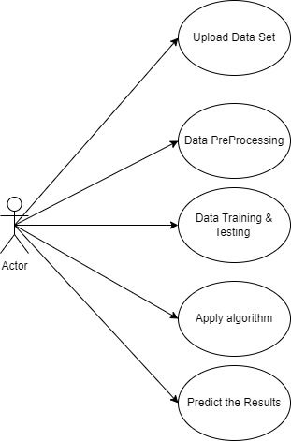
SEQUENCE DIAGRAM:
A sequence diagram in Unified Modeling Language (UML) is a kind of interaction diagram that shows how processes operate with one another and in what order. It is a construct of a Message Sequence Chart. Sequence diagrams are sometimes called event diagrams, event scenarios, and timing diagrams.

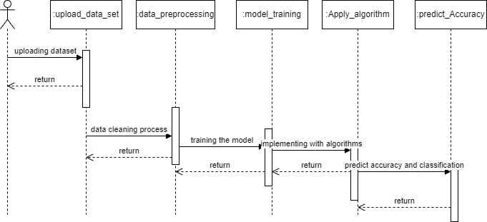
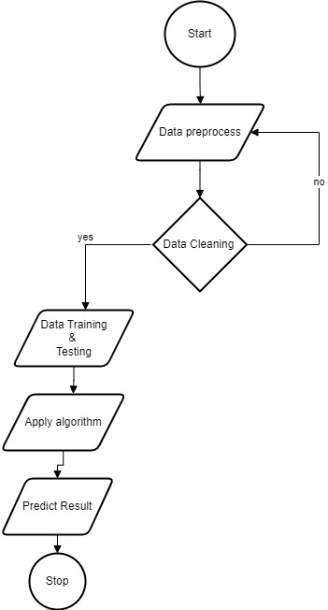
CLASS DIAGRAM:
In software engineering, a class diagram in the Unified Modeling Language (UML) is a type of static structure diagram that describes the structure of a system by showing the system's classes, their attributes, operations (or methods), and the relationships among the classes. It explains which class contains information.

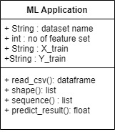

SOFTWARE ENVIRONMENT

What is Python?
Below are some facts about Python.
- Python is currently the most widely used multi-purpose, high-level programming language.
- Python allows programming in Object-Oriented and Procedural paradigms. Python programs generally are smaller than other programming languages like Java.
- Programmers have to type relatively less and indentation requirement of the language, makes them readable all the time.
- Python language is being used by almost all tech-giant companies like – Google, Amazon, Facebook, Instagram, Dropbox, Uber… etc.
The biggest strength of Python is huge collection of standard library which can be used for the following –
  - Machine Learning
  - GUI Applications (like Kivy, Tkinter, PyQt etc. )
  - Web frameworks like Django (used by YouTube, Instagram, Dropbox)
  - Image processing (like Opencv, Pillow)
  - Web scraping (like Scrapy, BeautifulSoup, Selenium)
  - Test frameworks
  - Multimedia

Advantages of Python
Let’s see how Python dominates over other languages.
1. Extensive Libraries
Python downloads with an extensive library and it contain code for various purposes like regular expressions, documentation-generation, unit-testing, web browsers, threading, databases, CGI, email, image manipulation, and more. So, we don’t have to write the complete code for that manually.
2. Extensible
As we have seen earlier, Python can be extended to other languages. You can write some of your code in languages like C++ or C. This comes in handy, especially in projects.
3. Embeddable
Complimentary to extensibility, Python is embeddable as well. You can put your Python code in your source code of a different language, like C++. This lets us add scripting capabilities to our code in the other language.
4. Improved Productivity
The language’s simplicity and extensive libraries render programmers more productive than languages like Java and C++ do. Also, the fact that you need to write less and get more things done.
5. IOT Opportunities
Since Python forms the basis of new platforms like Raspberry Pi, it finds the future bright for the Internet Of Things. This is a way to connect the language with the real world.
6. Simple and Easy
When working with Java, you may have to create a class to print ‘Hello World’. But in Python, just a print statement will do. It is also quite easy to learn, understand, and code. This is why when people pick up Python, they have a hard time adjusting to other more verbose languages like Java.
7. Readable
Because it is not such a verbose language, reading Python is much like reading English. This is the reason why it is so easy to learn, understand, and code. It also does not need curly braces to define blocks, and indentation is mandatory. This further aids the readability of the code.
8. Object-Oriented
This language supports both the procedural and object-oriented programming paradigms. While functions help us with code reusability, classes and objects let us model the real world. A class allows the encapsulation of data and functions into one.
9. Free and Open-Source
Like we said earlier, Python is freely available. But not only can you download Python for free, but you can also download its source code, make changes to it, and even distribute it. It downloads with an extensive collection of libraries to help you with your tasks.
10. Portable
When you code your project in a language like C++, you may need to make some changes to it if you want to run it on another platform. But it isn’t the same with Python. Here, you need to code only once, and you can run it anywhere. This is called Write Once Run Anywhere (WORA). However, you need to be careful enough not to include any system-dependent features.
11. Interpreted
Lastly, we will say that it is an interpreted language. Since statements are executed one by one, debugging is easier than in compiled languages.
Any doubts till now in the advantages of Python? Mention in the comment section.
Advantages of Python Over Other Languages
1. Less Coding
Almost all of the tasks done in Python requires less coding when the same task is done in other languages. Python also has an awesome standard library support, so you don’t have to search for any third-party libraries to get your job done. This is the reason that many people suggest learning Python to beginners.
2. Affordable
Python is free therefore individuals, small companies or big organizations can leverage the free available resources to build applications. Python is popular and widely used so it gives you better community support.
The 2019 Github annual survey showed us that Python has overtaken Java in the most popular programming language category.
3. Python is for Everyone
Python code can run on any machine whether it is Linux, Mac or Windows. Programmers need to learn different languages for different jobs but with Python, you can professionally build web apps, perform data analysis and machine learning, automate things, do web scraping and also build games and powerful visualizations. It is an all-rounder programming language.
Disadvantages of Python
So far, we’ve seen why Python is a great choice for your project. But if you choose it, you should be aware of its consequences as well. Let’s now see the downsides of choosing Python over another language.
1. Speed Limitations
We have seen that Python code is executed line by line. But since Python is interpreted, it often results in slow execution. This, however, isn’t a problem unless speed is a focal point for the project. In other words, unless high speed is a requirement, the benefits offered by Python are enough to distract us from its speed limitations.
2. Weak in Mobile Computing and Browsers
While it serves as an excellent server-side language, Python is much rarely seen on the client-side. Besides that, it is rarely ever used to implement smartphone-based applications. One such application is called Carbonnelle.
The reason it is not so famous despite the existence of Brython is that it isn’t that secure.
3. Design Restrictions
As you know, Python is dynamically-typed. This means that you don’t need to declare the type of variable while writing the code. It uses duck-typing. But wait, what’s that? Well, it just means that if it looks like a duck, it must be a duck. While this is easy on the programmers during coding, it can raise run-time errors.
4. Underdeveloped Database Access Layers
Compared to more widely used technologies like JDBC (Java DataBase Connectivity) and ODBC (Open DataBase Connectivity), Python’s database access layers are a bit underdeveloped. Consequently, it is less often applied in huge enterprises.
5. Simple
No, we’re not kidding. Python’s simplicity can indeed be a problem. Take my example. I don’t do Java, I’m more of a Python person. To me, its syntax is so simple that the verbosity of Java code seems unnecessary.
This was all about the Advantages and Disadvantages of Python Programming Language.
History of Python
What do the alphabet and the programming language Python have in common? Right, both start with ABC. If we are talking about ABC in the Python context, it's clear that the programming language ABC is meant. ABC is a general-purpose programming language and programming environment, which had been developed in the Netherlands, Amsterdam, at the CWI (Centrum Wiskunde &Informatica). The greatest achievement of ABC was to influence the design of Python. Python was conceptualized in the late 1980s. Guido van Rossum worked that time in a project at the CWI, called Amoeba, a distributed operating system. In an interview with Bill Venners¹, Guido van Rossum said: "In the early 1980s, I worked as an implementer on a team building a language called ABC at Centrum voor Wiskunde en Informatica (CWI). I don't know how well people know ABC's influence on Python. I try to mention ABC's influence because I'm indebted to everything I learned during that project and to the people who worked on it. "Later on in the same Interview, Guido van Rossum continued: "I remembered all my experience and some of my frustration with ABC. I decided to try to design a simple scripting language that possessed some of ABC's better properties, but without its problems. So I started typing. I created a simple virtual machine, a simple parser, and a simple runtime. I made my own version of the various ABC parts that I liked. I created a basic syntax, used indentation for statement grouping instead of curly braces or begin-end blocks, and developed a small number of powerful data types: a hash table (or dictionary, as we call it), a list, strings, and numbers."

Python Development Steps
Guido Van Rossum published the first version of Python code (version 0.9.0) at alt.sources in February 1991. This release included already exception handling, functions, and the core data types of list, dict, str and others. It was also object oriented and had a module system.
Python version 1.0 was released in January 1994. The major new features included in this release were the functional programming tools lambda, map, filter and reduce, which Guido Van Rossum never liked. Six and a half years later in October 2000, Python 2.0 was introduced. This release included list comprehensions, a full garbage collector and it was supporting unicode. Python flourished for another 8 years in the versions 2.x before the next major release as Python 3.0 (also known as "Python 3000" and "Py3K") was released. Python 3 is not backwards compatible with Python 2.x. The emphasis in Python 3 had been on the removal of duplicate programming constructs and modules, thus fulfilling or coming close to fulfilling the 13th law of the Zen of Python: "There should be one -- and preferably only one -- obvious way to do it."Some changes in Python 7.3:
- Print is now a function.
- Views and iterators instead of lists
- The rules for ordering comparisons have been simplified. E.g., a heterogeneous list cannot be sorted, because all the elements of a list must be comparable to each other.
- There is only one integer type left, i.e., int. long is int as well.
- The division of two integers returns a float instead of an integer. "//" can be used to have the "old" behaviour.
- Text Vs. Data Instead of Unicode Vs. 8-bit
Purpose
We demonstrated that our approach enables successful segmentation of intra-retinal layers—even with low-quality images containing speckle noise, low contrast, and different intensity ranges throughout—with the assistance of the ANIS feature.
Python
Python is an interpreted high-level programming language for general-purpose programming. Created by Guido van Rossum and first released in 1991, Python has a design philosophy that emphasizes code readability, notably using significant whitespace.
Python features a dynamic type system and automatic memory management. It supports multiple programming paradigms, including object-oriented, imperative, functional and procedural, and has a large and comprehensive standard library.
- Python is Interpreted − Python is processed at runtime by the interpreter. You do not need to compile your program before executing it. This is similar to PERL and PHP.
- Python is Interactive − you can actually sit at a Python prompt and interact with the interpreter directly to write your programs.
Python also acknowledges that speed of development is important. Readable and terse code is part of this, and so is access to powerful constructs that avoid tedious repetition of code. Maintainability also ties into this may be an all but useless metric, but it does say something about how much code you have to scan, read and/or understand to troubleshoot problems or tweak behaviors. This speed of development, the ease with which a programmer of other languages can pick up basic Python skills and the huge standard library is key to another area where Python excels. All its tools have been quick to implement, saved a lot of time, and several of them have later been patched and updated by people with no Python background - without breaking.
Modules Used in Project
TensorFlow
TensorFlow is a free and open-source software library for dataflow and differentiable programming across a range of tasks. It is a symbolic math library and is also used for machine learning applications such as neural networks. It is used for both research and production at Google.‍
TensorFlow was developed by the Google Brain team for internal Google use. It was released under the Apache 2.0 open-source license on November 9, 2015.
NumPy
NumPy is a general-purpose array-processing package. It provides a high-performance multidimensional array object, and tools for working with these arrays.
It is the fundamental package for scientific computing with Python. It contains various features including these important ones:
- A powerful N-dimensional array object
- Sophisticated (broadcasting) functions
- Tools for integrating C/C++ and Fortran code
- Useful linear algebra, Fourier transform, and random number capabilities
Besides its obvious scientific uses, NumPy can also be used as an efficient multi-dimensional container of generic data. Arbitrary datatypes can be defined using NumPy which allows NumPy to seamlessly and speedily integrate with a wide variety of databases.
Pandas
Pandas is an open-source Python Library providing high-performance data manipulation and analysis tool using its powerful data structures. Python was majorly used for data munging and preparation. It had very little contribution towards data analysis. Pandas solved this problem. Using Pandas, we can accomplish five typical steps in the processing and analysis of data, regardless of the origin of data load, prepare, manipulate, model, and analyze. Python with Pandas is used in a wide range of fields including academic and commercial domains including finance, economics, Statistics, analytics, etc.
Matplotlib
Matplotlib is a Python 2D plotting library which produces publication quality figures in a variety of hardcopy formats and interactive environments across platforms. Matplotlib can be used in Python scripts, the Python and IPython shells, the Jupyter Notebook, web application servers, and four graphical user interface toolkits. Matplotlib tries to make easy things easy and hard things possible. You can generate plots, histograms, power spectra, bar charts, error charts, scatter plots, etc., with just a few lines of code. For examples, see the sample plots and thumbnail gallery.
For simple plotting the pyplot module provides a MATLAB-like interface, particularly when combined with IPython. For the power user, you have full control of line styles, font properties, axes properties, etc, via an object oriented interface or via a set of functions familiar to MATLAB users.
Scikit – learn
Scikit-learn provides a range of supervised and unsupervised learning algorithms via a consistent interface in Python. It is licensed under a permissive simplified BSD license and is distributed under many Linux distributions, encouraging academic and commercial use. Python
Python is an interpreted high-level programming language for general-purpose programming. Created by Guido van Rossum and first released in 1991, Python has a design philosophy that emphasizes code readability, notably using significant whitespace.
Python features a dynamic type system and automatic memory management. It supports multiple programming paradigms, including object-oriented, imperative, functional and procedural, and has a large and comprehensive standard library.
- Python is Interpreted − Python is processed at runtime by the interpreter. You do not need to compile your program before executing it. This is similar to PERL and PHP.
- Python is Interactive − you can actually sit at a Python prompt and interact with the interpreter directly to write your programs.
Python also acknowledges that speed of development is important. Readable and terse code is part of this, and so is access to powerful constructs that avoid tedious repetition of code. Maintainability also ties into this may be an all but useless metric, but it does say something about how much code you have to scan, read and/or understand to troubleshoot problems or tweak behaviors. This speed of development, the ease with which a programmer of other languages can pick up basic Python skills and the huge standard library is key to another area where Python excels. All its tools have been quick to implement, saved a lot of time, and several of them have later been patched and updated by people with no Python background - without breaking.
Install Python Step-by-Step in Windows and Mac
Python a versatile programming language doesn’t come pre-installed on your computer devices. Python was first released in the year 1991 and until today it is a very popular high-level programming language. Its style philosophy emphasizes code readability with its notable use of great whitespace.
The object-oriented approach and language construct provided by Python enables programmers to write both clear and logical code for projects. This software does not come pre-packaged with Windows.
How to Install Python on Windows and Mac
There have been several updates in the Python version over the years. The question is how to install Python? It might be confusing for the beginner who is willing to start learning Python but this tutorial will solve your query. The latest or the newest version of Python is version 3.7.4 or in other words, it is Python 3.
Note: The python version 3.7.4 cannot be used on Windows XP or earlier devices.
Before you start with the installation process of Python. First, you need to know about your System Requirements. Based on your system type i.e. operating system and based processor, you must download the python version. My system type is a Windows 64-bit operating system. So the steps below are to install python version 3.7.4 on Windows 7 device or to install Python 3. Download the Python Cheatsheet here.The steps on how to install Python on Windows 10, 8 and 7 are divided into 4 parts to help understand better.
Download the Correct version into the system
Step 1: Go to the official site to download and install python using Google Chrome or any other web browser. OR Click on the following link: https://www.python.org
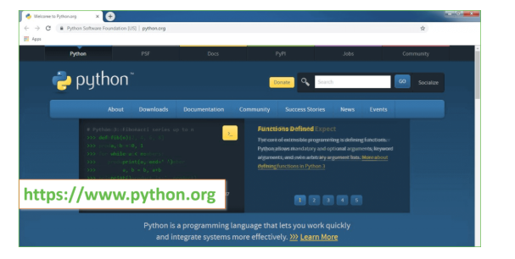
Now, check for the latest and the correct version for your operating system.
Step 2: Click on the Download Tab.
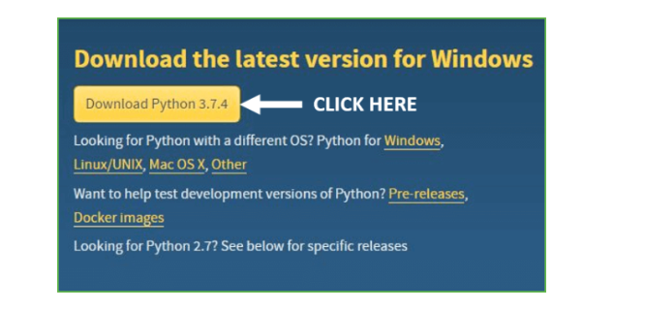
Step 3: You can either select the Download Python for windows 3.7.4 button in Yellow Color or you can scroll further down and click on download with respective to their version. Here, we are downloading the most recent python version for windows 3.7.4
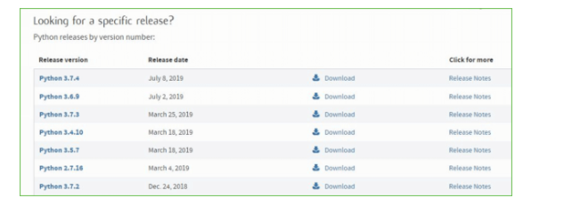
Step 4: Scroll down the page until you find the Files option.
Step 5: Here you see a different version of python along with the operating system.
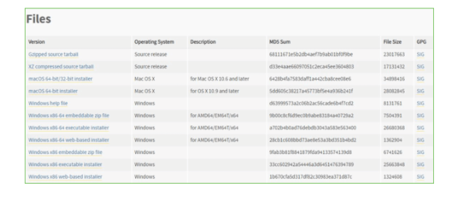
- To download Windows 32-bit python, you can select any one from the three options: Windows x86 embeddable zip file, Windows x86 executable installer or Windows x86 web-based installer.
- To download Windows 64-bit python, you can select any one from the three options: Windows x86-64 embeddable zip file, Windows x86-64 executable installer or Windows x86-64 web-based installer.
Here we will install Windows x86-64 web-based installer. Here your first part regarding which version of python is to be downloaded is completed. Now we move ahead with the second part in installing python i.e. Installation
Note: To know the changes or updates that are made in the version you can click on the Release Note Option.
Installation of Python
Step 1: Go to Download and Open the downloaded python version to carry out the installation process.
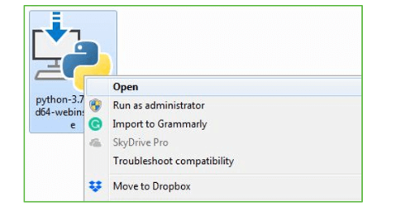
Step 2: Before you click on Install Now, Make sure to put a tick on Add Python 3.7 to PATH.
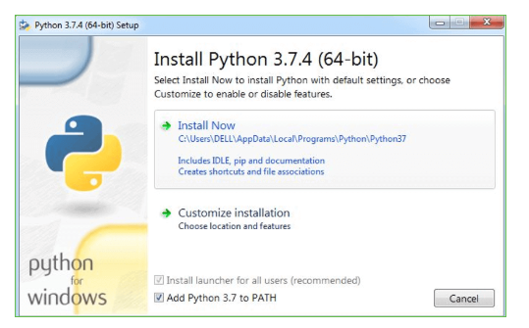
Step 3: Click on Install NOW After the installation is successful. Click on Close.
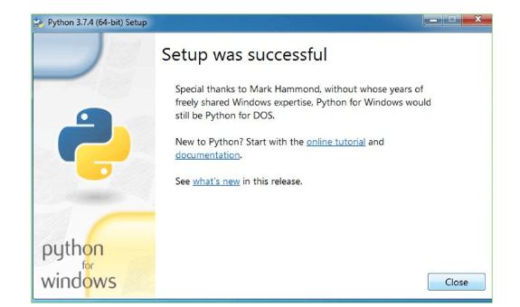
With these above three steps on python installation, you have successfully and correctly installed Python. Now is the time to verify the installation.
Note: The installation process might take a couple of minutes.
Verify the Python Installation
Step 1: Click on Start
Step 2: In the Windows Run Command, type “cmd”.

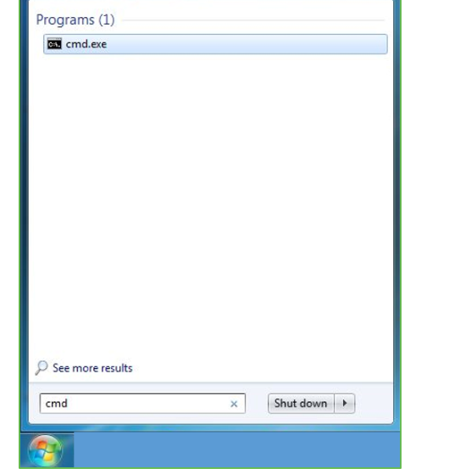
Step 3: Open the Command prompt option.
Step 4: Let us test whether the python is correctly installed. Type python –V and press Enter.
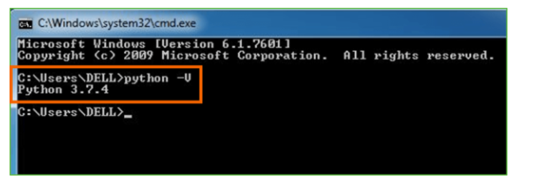
Step 5: You will get the answer as 3.7.4
Note: If you have any of the earlier versions of Python already installed. You must first uninstall the earlier version and then install the new one.
Check how the Python IDLE works
Step 1: Click on Start
Step 2: In the Windows Run command, type “python idle”.
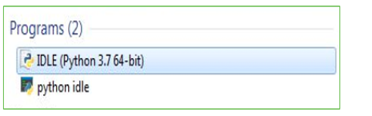
Step 3: Click on IDLE (Python 3.7 64-bit) and launch the program
Step 4: To go ahead with working in IDLE you must first save the file. Click on File > Click on Save
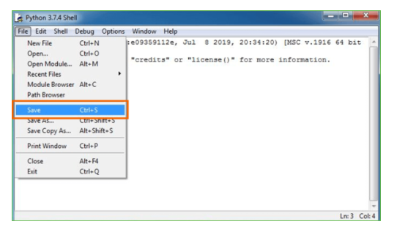
Step 5: Name the file and save as type should be Python files. Click on SAVE. Here I have named the files as Hey World.
Step 6: Now for e.g. enter print (“Hey World”) and Press Enter.
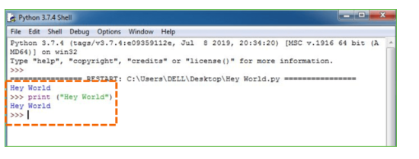
You will see that the command given is launched. With this, we end our tutorial on how to install Python. You have learned how to download python for windows into your respective operating system.
Note: Unlike Java, Python does not need semicolons at the end of the statements otherwise it won’t work.

ALGORITHM INFORMATION:
Decision Tree (DT):
A flowchart-like structure where decisions are made based on features in the data. It asks a series of yes/no questions to reach a final prediction, making it interpretable. DTs are good for both classification and regression tasks.
Support Vector Classifier (SVC):
Finds a hyperplane that best separates data points of different classes with the maximum margin. SVMs are effective in high-dimensional data and for problems with few training samples.

Random Forest:
Random Forest is an ensemble learning algorithm that builds multiple decision trees and combines their predictions to improve accuracy and reduce overfitting. It works by randomly selecting subsets of data and features for training each tree, making it robust against noise. This algorithm is widely used for classification and regression tasks due to its high performance and interpretability.

Logistic Regression:
Logistic Regression is a statistical method used for binary classification, predicting the probability of an event occurring based on input features. It applies the sigmoid function to transform linear combinations of variables into probabilities ranging between 0 and 1. This algorithm is simple, efficient, and widely used in applications such as fraud detection and medical diagnosis.

TESTING:
RESULT:
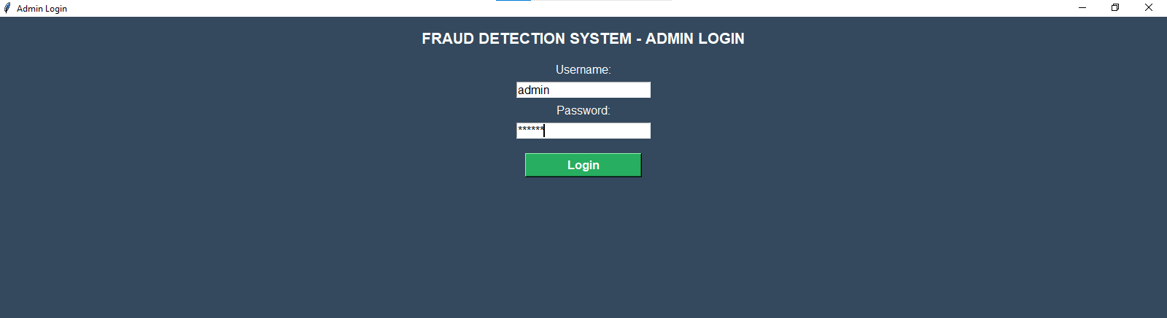
Login Button: This button verifies the user’s credentials by comparing them with predefined values. If correct, it closes the login window and opens the main page; otherwise, it shows an error message

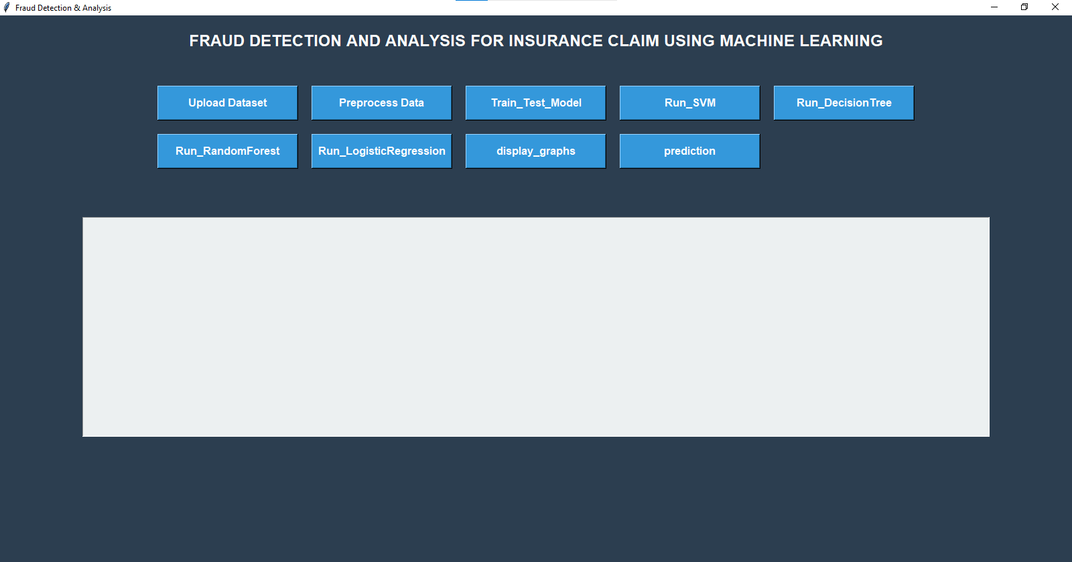

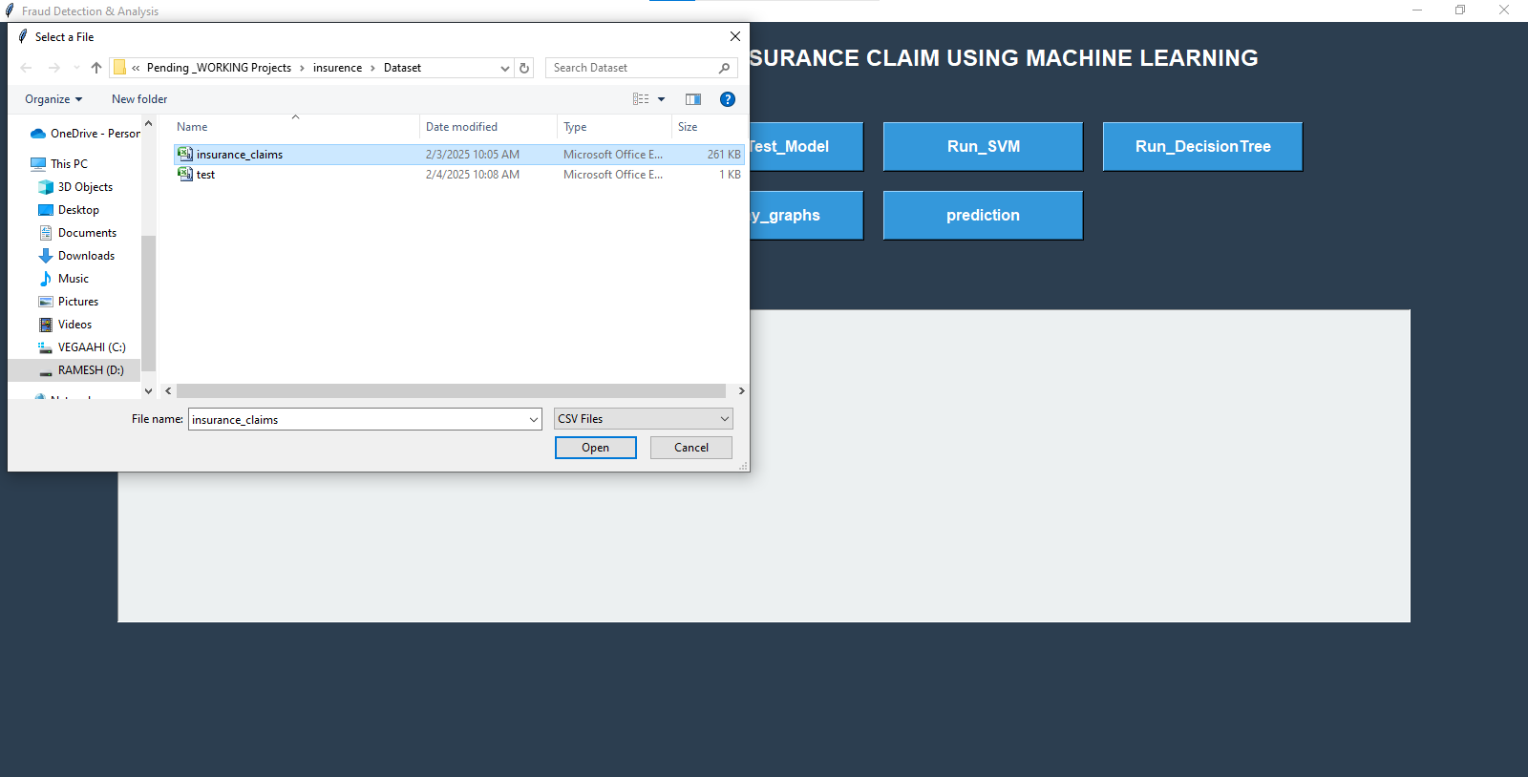

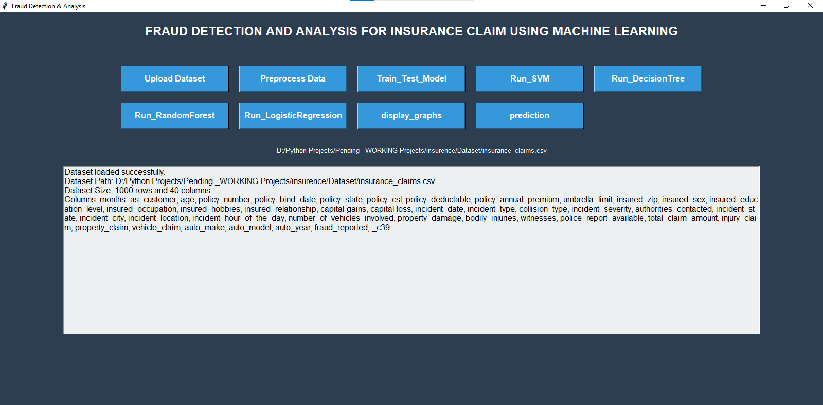
Upload Dataset Button: This button prompts the user to upload a CSV file using a file dialog. The dataset is read, missing values are handled, and basic dataset details like size and columns are displayed in a text box.

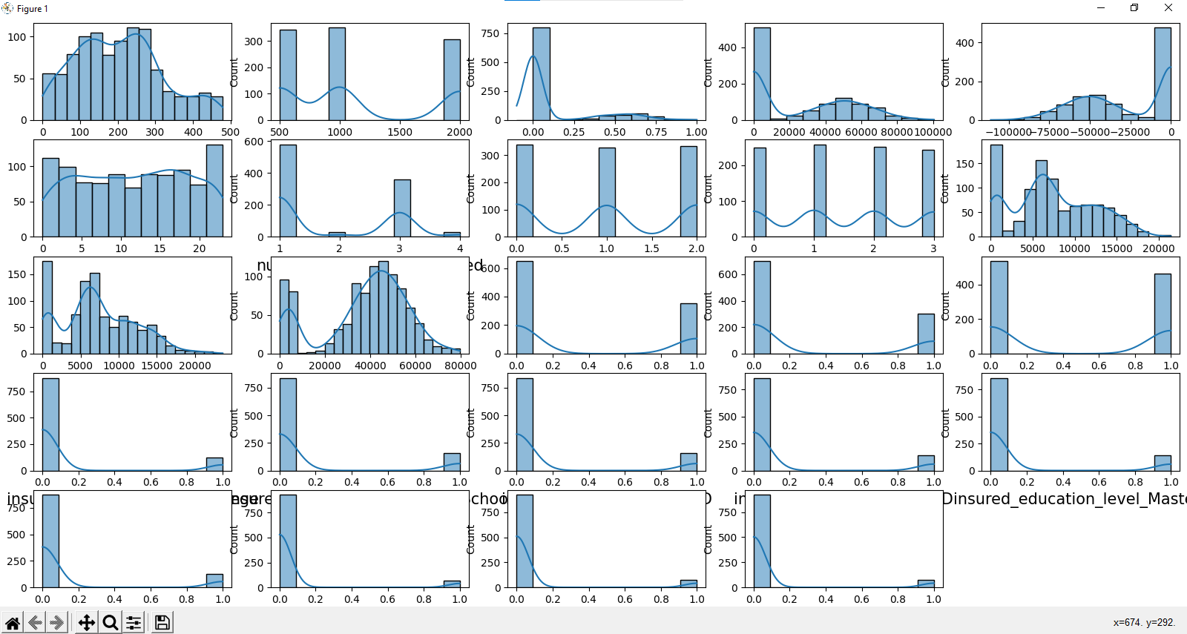

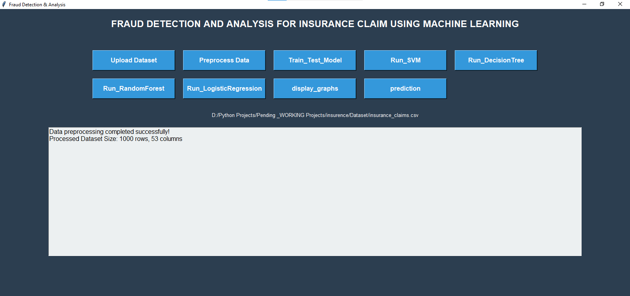
Preprocess Data Button: This button performs preprocessing tasks such as handling missing values, dropping irrelevant columns, and encoding categorical features. It also generates histograms to visualize the processed data.

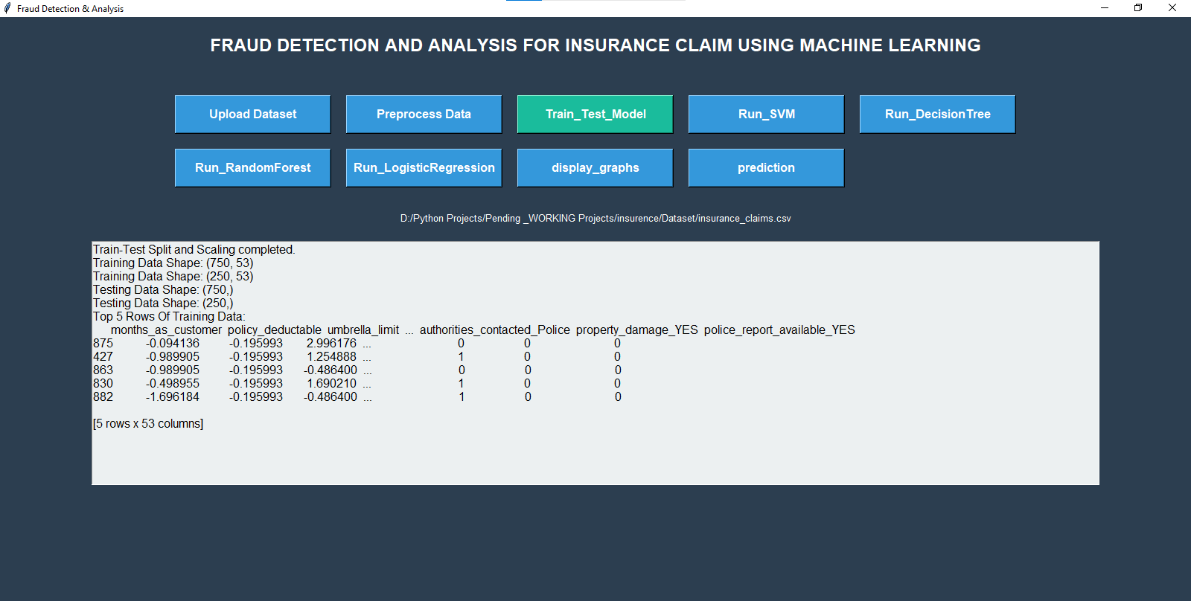
Train-Test Split Button: This button splits the dataset into training and testing sets, applies scaling to the numeric features, and updates the display with the shape of the datasets and a preview of the training data.

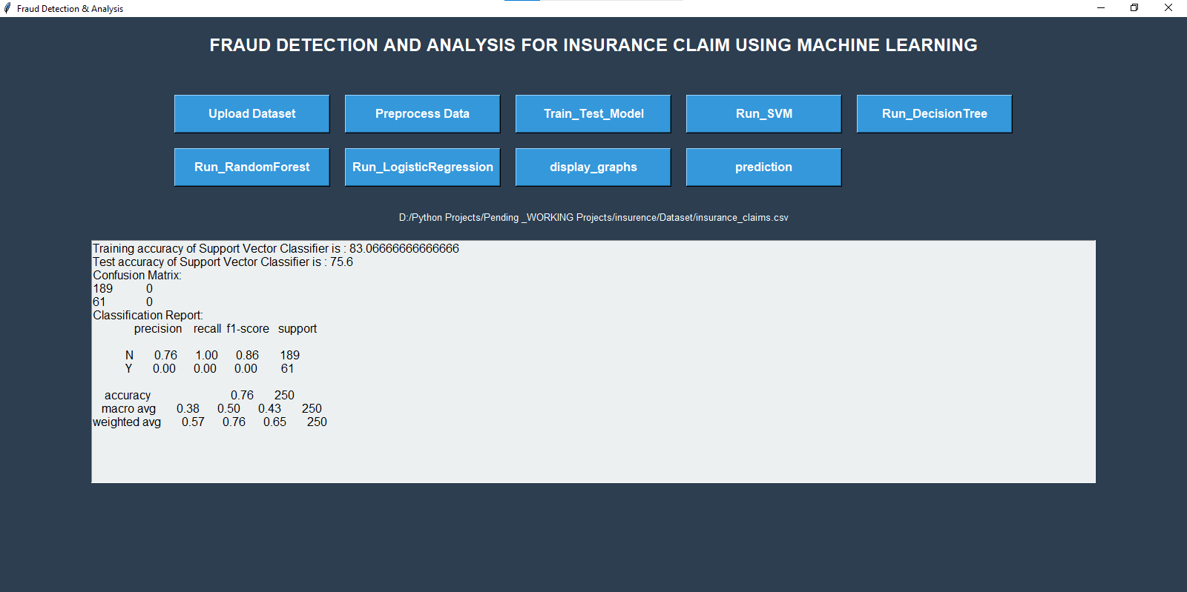
SVM Classifier Button: This button trains a Support Vector Machine (SVM) model, calculates training and testing accuracy, and displays confusion matrix and classification report in the text box.

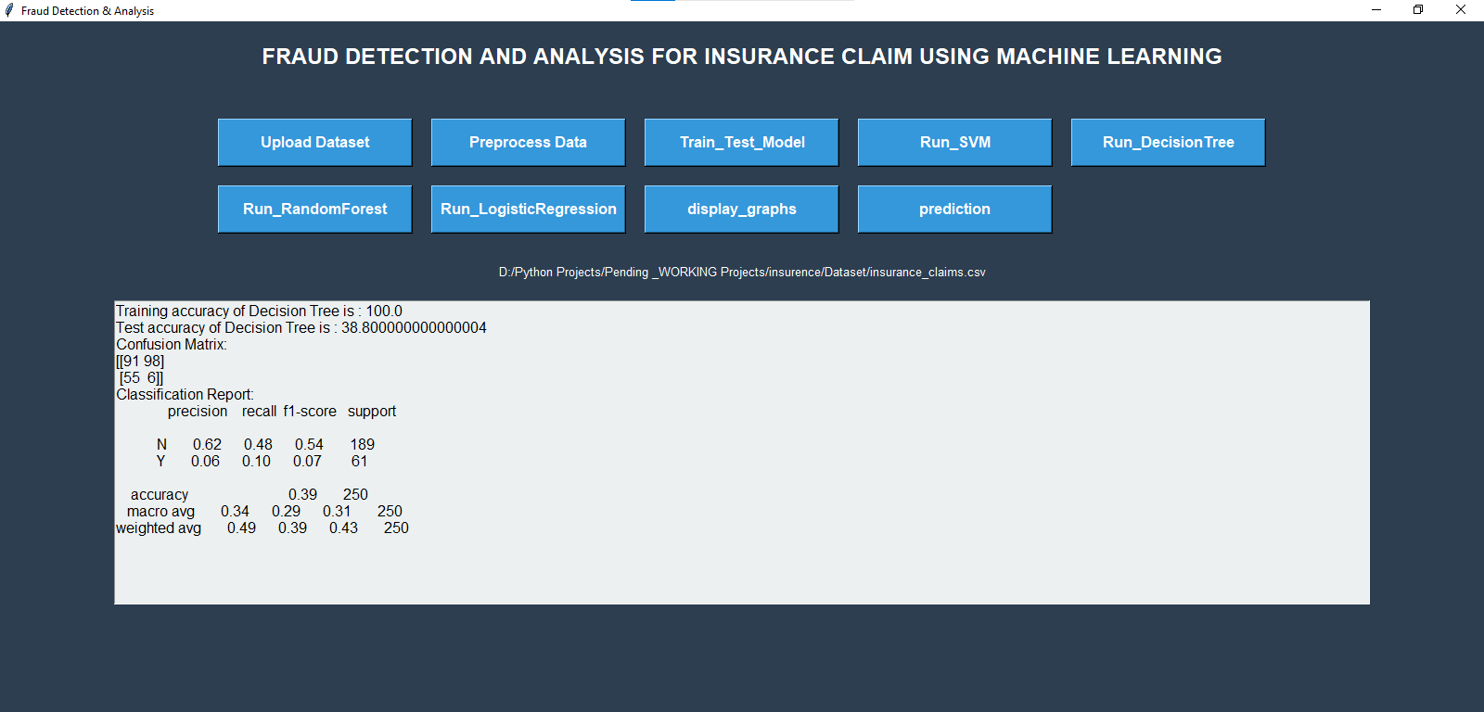
Decision Tree Classifier Button: This button trains a Decision Tree model, calculates its training and testing accuracy, and displays the confusion matrix and classification report for evaluation.

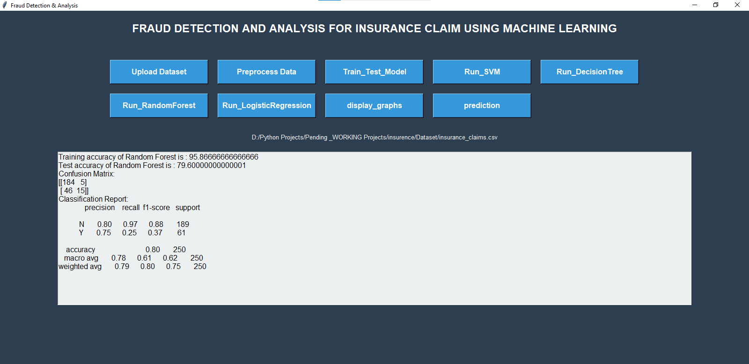
Random Forest Classifier Button: This button trains a Random Forest model, calculates its training and testing accuracy, and outputs the confusion matrix and classification report for performance evaluation.

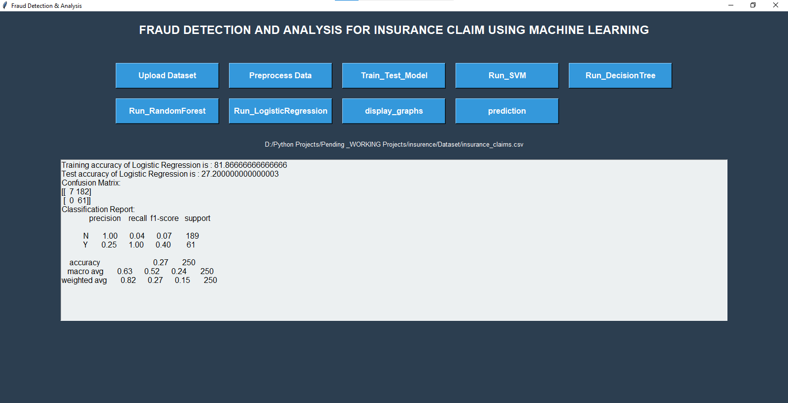
Logistic Regression Button: This button trains a Logistic Regression model, computes the training and testing accuracy, and presents the confusion matrix and classification report to assess the model’s performance.

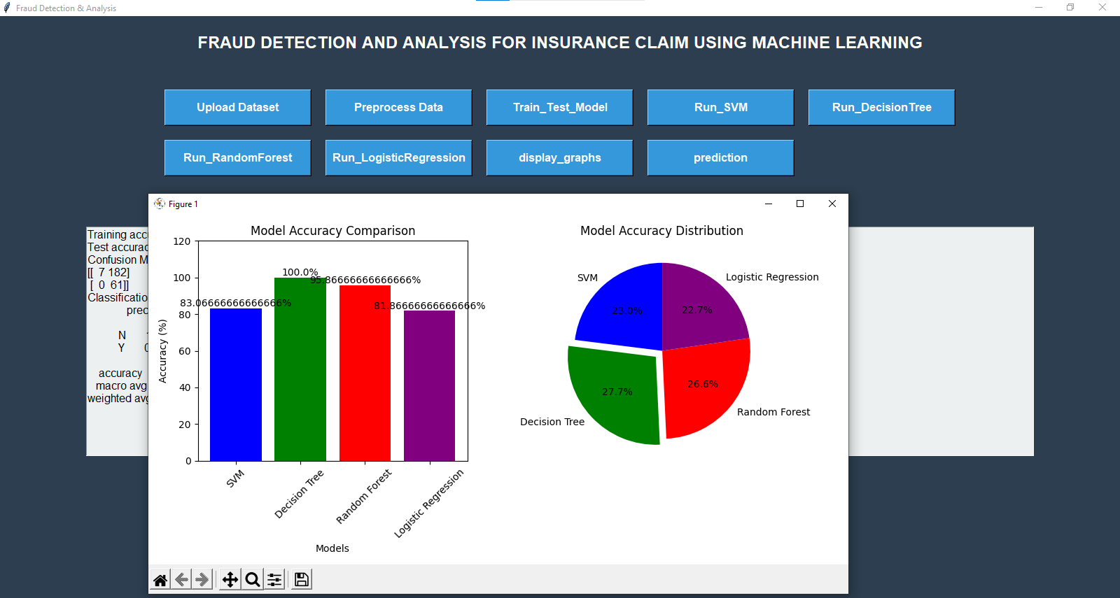
Display Graphs Button: This button creates and displays a bar graph comparing the training accuracies of the SVM, Decision Tree, Random Forest, and Logistic Regression models for visual performance comparison.

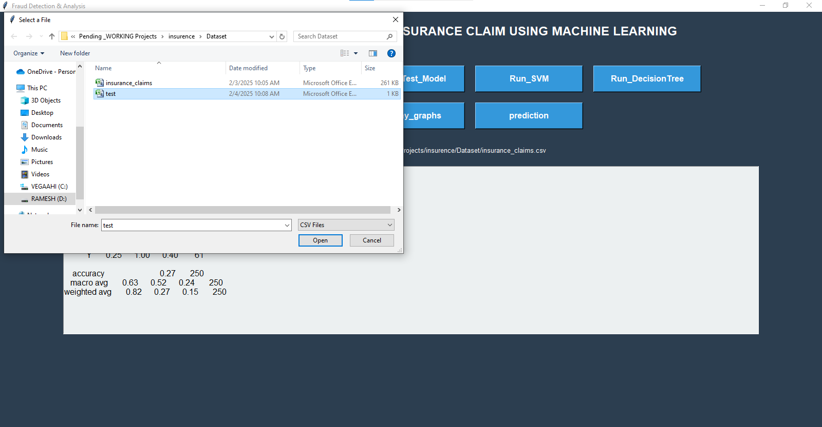

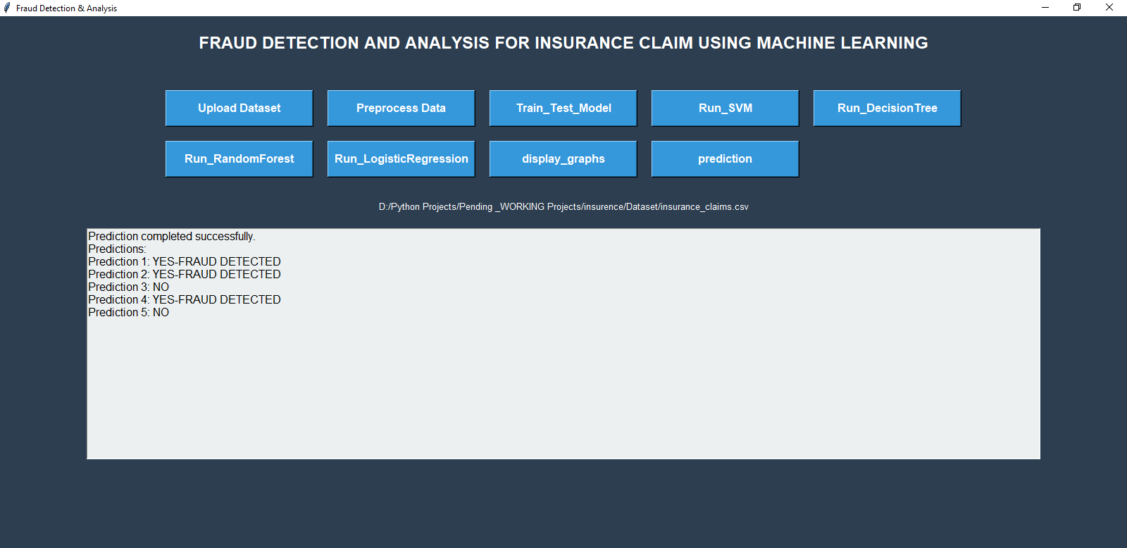
Prediction: To predict the result using the Decision Tree algorithm, you first need to train a Decision Tree model on your dataset and then make predictions with it.

CONCLUTION:
The machine learning models applied to these datasets effectively identified most fraudulent cases with a low false positive rate, demonstrating high accuracy. However, certain datasets faced significant data quality challenges, which led to lower prediction performance. Given the unique characteristics of each dataset, it is not advisable to define a universal optimal algorithm or feature engineering process for better performance. The models should be tailored for specific business contexts and user priorities, allowing fraud detection units to focus on emerging fraud patterns and ensure that models are adapting accordingly. Based on the model's performance during backtesting and its ability to detect new fraud, the set of models seems to be a reasonable choice for use in insurance claims fraud detection.

REFERENCES:
[1] K. Ulaga Priya and S. Pushpa, “A Survey on Fraud Analytics Using Predictive Model in Insurance Claims,” Int. J. Pure Appl. Math., vol. 114, no. 7, pp. 755–767, 2017.
[2] E. B. Belhadji, G. Dionne, and F. Tarkhani, “A Model for the Detection of Insurance Fraud,” Geneva Pap. Risk Insur. Issues Pract., vol. 25, no. 4, pp. 517– 538, 2000, doi: 10.1111/1468-0440.00080.
[3] “Predictive Analysis for Fraud Detection.” https://www.wipro.com/analytics/comparati veanalysis-of-machine-learning-techniquesfor-%0Adetectin/.
[4] F. C. Li, P. K. Wang, and G. E. Wang, “Comparison of the primitive classifiers with extreme learning machine in credit scoring,” IEEM 2009 - IEEE Int. Conf. Ind. Eng. Eng. Manag., vol. 2, no. 4, pp. 685– 688, 2009, doi: 10.1109/IEEM.2009.5373241.
[5] V. Khadse, P. N. Mahalle, and S. V. Biraris, “An Empirical Comparison of Supervised Machine Learning Algorithms for Internet of Things Data,” Proc. - 2018 4th Int. Conf. Comput. Commun. Control Autom. ICCUBEA 2018, pp. 1–6, 2018, doi: 10.1109/ICCUBEA.2018.8697476.
[6] S. Ray, “A Quick Review of Machine Learning Algorithms,” Proc. Int. Conf. Mach. Learn. Big Data, Cloud Parallel Comput. Trends, Prespectives Prospect. Com. 2019, pp. 35–39, 2019, doi: 10.1109/COMITCon.2019.8862451.

